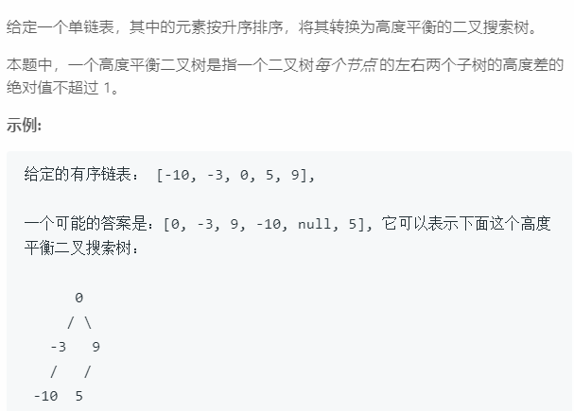

/\*\*

\* Definition for singly-linked list.

\* struct ListNode {

\* int val;

\* ListNode \*next;

\* ListNode(int x) : val(x), next(NULL) {}

\* };

\*/

/\*\*

\* Definition for a binary tree node.

\* struct TreeNode {

\* int val;

\* TreeNode \*left;

\* TreeNode \*right;

\* TreeNode(int x) : val(x), left(NULL), right(NULL) {}

\* };

\*/

class Solution {

public:

TreeNode\* sortedListToBST(ListNode\* head) {

if(!head) return NULL;

if(!head->next) return new TreeNode(head->val);

ListNode \*doub=head,\*sing=head,\*pre=head;

int k=0;

while(doub->next)

{

doub=doub->next;

k++;

if(k%2==0)

{

pre=sing;

sing=sing->next;

}

}

doub=sing->next;

pre->next=NULL;

TreeNode \*res=new TreeNode(sing->val);

if(head!=sing) res->left=sortedListToBST(head);

res->right=sortedListToBST(doub);

return res;

}

};